# CS 255 System Design Document Template

## UML Diagrams

### UML Use Case Diagram

### UML Activity Diagrams

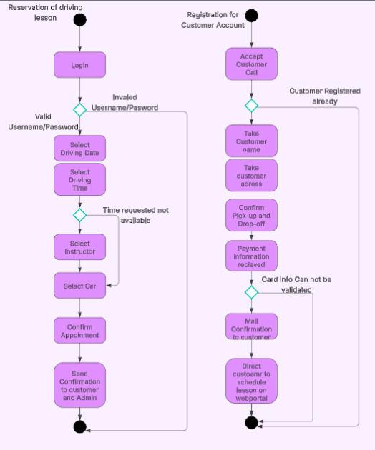

### UML Sequence Diagram

### UML Class Diagram

## Technical Requirements

Given the business’s modest size and potential for growth, adopting a cloud-based server is advisable due to its affordability and scalability. All administrative personnel should be equipped with computers running a Windows operating system to ensure seamless access to the system. An automated backup solution is essential for safeguarding sensitive data, including customer and administrative records, and must be complemented by robust antivirus software to protect against security threats. A stable internet connection is critical for administrative staff to stay updated on schedule changes, reservations, and policy updates from the DMV. Additionally, DriverPass’s web portal should be accessible across major platforms MacOS, Windows, iOS, and Android to maximize customer reach.